The items of the Fire Safety Regulations of Gulf RE, Ltd. which are mandatory to and to be observed by the employees of the lessees of the premises at Smilšu street 3

24. The obligations of the employees with regard to the preventive measures for the identification of fire risks:
24.1. Not to admit outbreak or fire;
24.2. To participate in the process of the fire safety training;

24.3. To maintain order in the place of work and tidy it after the work has ended;
24.4. To comply with the fire safety requirements while performing the job duties;
24.5. To know the escape routes within the facility;
24.6. To respect the safety signs posted in the facility and know their meaning;
24.7. To acquire the requirements of the fire safety instruction and know how to act in the event of fire;
24.8. To know the locations of the fire extinguishers available at the facility and be able to operate/use any such fire-extinguishing products;
24.9. To exercise particular caution when handling any combustible or explosive materials. When handling them, the requirements provided in the labelling and the warning texts on the packaging or in the accompanying documents.

25. The following shall be prohibited within the facility:
25.1. To block up the accesses to the fire extinguishers and automatic fire alarm system detectors;
25.2. To block up the escape routes and exits;
25.3. To burn candles, sparklers, pyrotechnic and other items, fluids with open flame;
25.4. To use substances and materials with unknown fire risk and explosion risk properties as well as store any such substances and materials in the premises of the facility;
25.5. To carry out/perform any activities which may cause fire;
25.6. To smoke in the premises and any territories other than the specially designated areas labelled with the respective safety sign;
25.7. To put any combustible items in any locations not intended for them.

27. Obligations of the employees and lessees with regard to the maintenance of escape and access roads:
27.1. Not to block up the escape routes and the emergency exit doors with any furniture, equipment or items (flower pots, copying devices etc.);

27.2. Not to place any items which prevent access to the fire-extinguishing systems and devices.

Action in the event of fire

49. In event of fire, the person responsible for fire safety shall:
49.1. Upon the receipt of information about fire, press the nearest manual alarm button in case the automatic fire alarm system has not been activated;
49.2. Make sure that information about fire has been delivered to the employees;
49.3. Make every effort to avoid potential panic by calming the people and to inform about the expected action constructively;
49.4. Assemble the employees at a safe meeting point - at the facade of the building at 7 Smilšu Street;
49.5. Wait for the officials of the Fire-fighting and Rescue Service (henceforth referred to as FFRS), provide information about the course of evacuation, and show the shortest routes to the location of the fire;
49.6. Inform the FFRS official about any people which are or might be at the location of the fire;
49.7. After the arrival of the FFRS, obey the manager of the fire-extinguishing and rescue operations and act in accordance with their instructions;

50. Obligations of the employees and the employees of the lessees of any premises within the facility in the event of fire:
50.1. Upon hearing the fire alarm, noticing any fire or receipt of information about fire, leave the building immediately using the nearest available emergency exit and head towards the safe assembly point - at the facade of the building at 7 Smilšu Street;
50.2. In case the automatic fire alarm system has not been activated, press the nearest manual alarm button on the way to the escape exit;
50.3. Report the fire to the FFRS by calling 112;
50.4. Stay at the safe assembly point until further instructions are received from the person responsible for fire safety or from the responsible person;
50.5. Leaving the safe assembly point without receiving permission from the responsible persons is prohibited;
50.6. Evaluate own abilities before putting the fire out with any fire-extinguishing products. Evacuate immediately if in any doubt about the ability to put the fire out independently.

53. Evacuation procedures:

53.1. Use the safest and shortest escape routes for evacuation;
53.2. Try to hold on to the handrails when using any stairs for evacuation;
53.3. In any smoke-filled or burning premises, crawl with the head as close to the floor as possible. When moving in a smoke-filled room, crawl near a wall in order not to lose the direction of orientation;
53.4. Do not re-enter the facility or the room until permitted to do so by the employees of the FFRS;
53.5. Stay calm and do not perform any hasty actions;
53.6. Follow the instructions given by the responsible employees;
53.7. Help other by showing them the nearest escape exit;
53.8. Follow the escape routes shown in the escape plans;
53.9. Move along the escape routes labelled with the door and human silhouette sign with an arrow in the direction of the escape exit or the exit sign (green);
53.10. Do not return under any circumstances because doing so may cause an obstruction and put your health and life or the health and life of others at risk;
53.11. Do not stand at the exit, but head towards the safe assembly point. Do not obstruct (block up) the path for those coming behind you as well as the assistance services (the police, fire-fighters or medical staff);
53.12. Do not use any elevators for evacuation.

54. If evacuation is not possible:
54.1. Stay where you are and try to make noise to attract attention and wait for help;

54.2. If the room has windows, open one just enough to attract the attention of the people nearby. Do not hold the window open all the time;
54.3. If you have not managed to escape from the facility due to obstructing fire or for any other reasons, try to contact the FFRS by calling and tell your location clearly and accurately;
54.4. Close the doors to the room and seal any apertures in order to prevent smoke from entering the room you are in;
54.5. If the room starts filling up with smoke, stay as close to the floor as possible, with tour face downwards. Cover your airways with a cloth to prevent smoke from entering the airways;
55. In the event of evacuation, the employees of the facility shall assist any people with special needs who might be present in the facility.

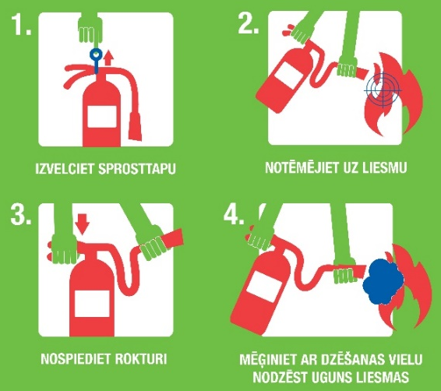
59. Use of a powder fire extinguisher:

H. Pāvuls, Boards Member of Gulf RE, Ltd.

